**TWO BIT HALF SUBTRACTOR**  
  
  
  
  
  
**EXP.NO: 22**  
  
   
  
**AIM:**  
  
To design and implement the two bit half subtractor  
using Logisim simulator.  
  
   
  
**PROCEDURE:**  
  
1)      Pick and place the necessary gates.  
  
2)      Insert 2  
inputs into the canvas.  
  
3)      Connect  
the inputs to the OR gate, AND gate and NOT gate.  
  
4)      Insert  
2 outputs into the canvas.  
  
5)   
  Make the connections using the  
connecting wires.  
  
6)      Verify the truth table.  
  
  
  
   
  
**TRUTH TABLE:**

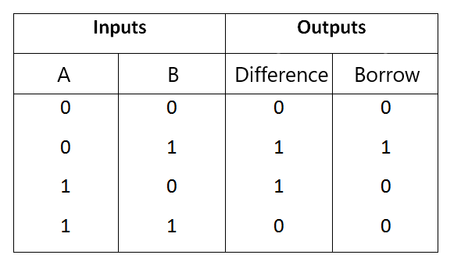  
  
**Difference = A ⊕ B  
Borrow = A' B**

   
  
**OUTPUT**

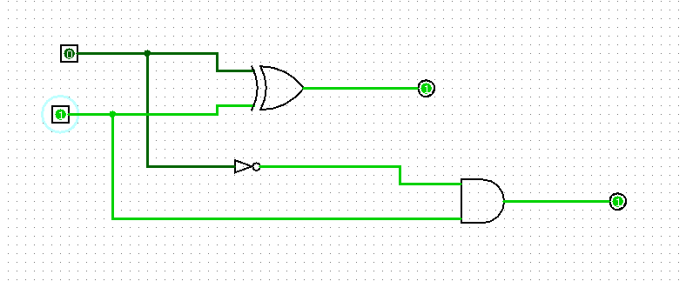  
  
  
  
  
  
**RESULT:**Thus 2-bit half subtractor has been designed and implemented successfully using logisim simulator.